Refund Single Item (https://www.useloom.com/share/976328cfbdb5462aa673e1614ca1302d)
- Open Shopify Admin Panel
- Click on ORDERS (left navigation)
- Select the Order number you want to refund.
- Scroll down the order page until you see the grey REFUND button. Click on the REFUND button.
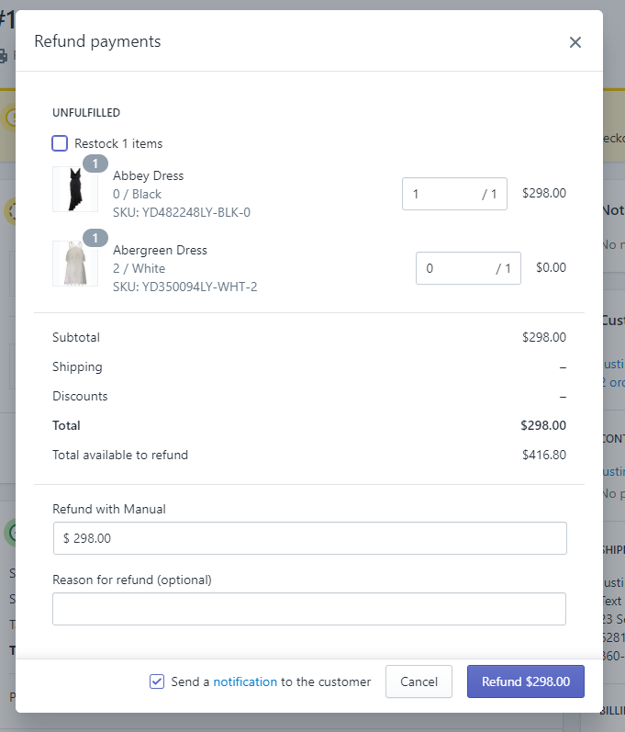
- On the Refund Payments area, fill in the following information as needed for your refund request.
Enter the Number of Items for each line item you are returning – Green Box
UN-Check the Restock Checkbox – Orange Box)
Adjust the Refund Amount if you need to account for shipping or defects you are charging the customer for. After updating this field verify the Total / Total Available to Refund – Purple Box
Enter a reason for the refund, reference the chart at the end of this document for the reasons you should enter into this box. – Blue Box
- Click the REFUND $XXX.00 purple button to process the refund.
NOTE: Refunds are NOT reversable, once you process the refund the refund will be applied to the customers original payment method.

Refund for Customer Credit or Customer Service Reasons (not returning an item).
(https://www.useloom.com/share/a7a2a7a138854be4b51006a319620872)
- Open Shopify Admin Panel
- Click on ORDERS (left navigation)
- Select the Order number you want to refund.
- Scroll down the order page until you see the grey REFUND button. Click on the REFUND button.
Enter the amount to refund in the REFUND WITH MANUAL box (purple box)
Enter a reason for the refund, reference the chart at the end of this document for the reasons you should enter into this box. – Blue Box
- Click the REFUND $XXX.00 purple button to process the refund.
NOTE: Refunds are NOT reversable, once you process the refund the refund will be applied to the customers original payment method.

To better track refunds and exchanges, following the format below will allow for greater reporting insights.

Refund Code | Reason
01 | Size to Small
02 | Size to Large
03 | Item Damaged
04 | Didn’t like color
05 | Didn’t like look / appearance
06 | Quality Issues
10 | New Order for Smaller Size
11 | New Order for Larger Size
12 | New Order for different color (same style)
13 | New Order for different product
20 | Out of Stock
21 | Error in Shipment
22 | Lost during Shipment
23 | Order arrived late
99 | Coupon / Discount Application

Reason for refund should look like this:

CODE | Description
CODE | NEW ORDER # | Description

Examples:
Size was too small:
01 | Dress was too small
Exchanged for larger size of same item:
11 | #1002 | Size was too small, new order for larger size
Discount code missed, issuing credit:
99 | Refunded LIKELY coupon code

